E-rate Funding Years – Dates to Remember
 | APPLICATION PROCESS |  |  |  | RECURRING SERVICES |  | NON-RECURRING EQUIMENT/SERVICES
 | Admin Window  EPC Profile Updates  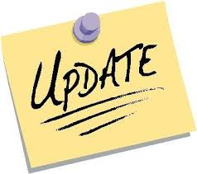 | Form 470 Competitive Bidding | Form 471 Application Window  to Request Discounts | Form 486  Service Start Date + CIPA Certification | Delivery Dates  (Category  1 or 2) | Form 472 BEAR Invoicing Deadline | Purchase/  Installation Dates  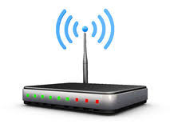 | Form 472 BEAR Invoicing Deadline
FY 2019 | Oct. 1, 2018  to  Jan. 7, 2019 | July 1, 2018  to  Feb. 20, 2019  (29-days before 471 deadline) | Jan 10, 2019  to  March 22, 2019 | 120 days from:  FCDL or  Service Start Date  (whichever is later) | July 1, 2019  to  June 30, 2020 | Oct. 28, 2020 | April 1, 2019  to  Sept. 30, 2020 | Jan. 28, 2021
FY 2018 | Closed | Closed | Closed | 120 days from:  FCDL or  Service Start Date  (whichever is later) | July 1, 2018  to  June 30, 2019 | Oct. 28, 2019 | April 1, 2018  to  Sept. 30, 2019 | Jan. 28, 2020
FY 2017 | Closed | Closed | Closed | 120 days from:  FCDL or  Service Start Date  (whichever is later) | July 1, 2017  to  June 30, 2018 | Oct. 28, 2018 | April 1, 2017  to  Sept. 30, 2018 | Jan. 28, 2019
Notes |  | Don’t bid if in an E-rate-valid, multi-year contract | A 471 must be filed every year to receive $$ | FCDL = Funding Commitment Decision Letter | Broadband, Internet, Voice, Maintenance Services are Recurring | May request one 120-day extension if submitted by BEAR deadline | Non-recurring = one-time purchases | May request one 120-day extension if submitted by BEAR deadline

